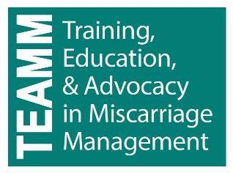
Counseling practice points for early pregnancy loss:
suggestions and phrases to support a patient-centered
approach to EPL care

Suggestions

- DO consider remaining silent after providing initial results or information, allowing the patient to process and experience her emotions. Follow up with open-ended questions and active listening.

- DO determine if the pregnancy is desired, as this will be important in helping the patient arrive at emotional resolution and a plan.

- DO normalize emotions and validate feelings.

- DO be thoughtful disclosing personal information. Avoid giving your personal opinions about what patients “should” do. Listen to the patient and focus on asking questions.

- DO encourage the patient to seek emotional support from others.

- DO provide reassurance. DON’T guarantee that “everything will be alright.”

- DO assure the patient that you will be available to her through the process and answer questions as they arise

- DO use neutral responses whenever possible.

Phrases/questions

- What is the hardest part of this for you?
- What would be helpful right now?

- Can you tell me about this pregnancy?
- When did you find out you were pregnant? Who knows you are pregnant?

- A wide range of feelings are normal.

- I’m happy to provide you with information about your pregnancy/miscarriage…. What would be helpful to you right now?

- Who might be helpful to talk to about your miscarriage?

- I know it’s hard right now…and we are here to help you through the process.

- We are here for you and are happy to answer your questions – now or after you go home.

- See back side for neutral phrases and questions

Neutral phrases and questions:

- That is a question a lot of people wonder about.

- I’m glad you asked that question.

- That’s a difficult question for me to answer…I’ll try and we may want to ask our provider.

- Tell me more about what is concerning you.

- What additional information might be helpful?

- A wide range of emotions are really normal.

- It is expected that you’ll have mixed feelings about this.

- Some other patients I have spoken with have experienced…

- It is my understanding that…

- How would that work for you?

- What would be helpful to you?

- What questions do you have?

- What’s the hardest part of this experience for you?

Adapted from Wallace, Robin R. et al: “Counseling women with early pregnancy failure: Utilizing evidence, preserving preference.” 2010

