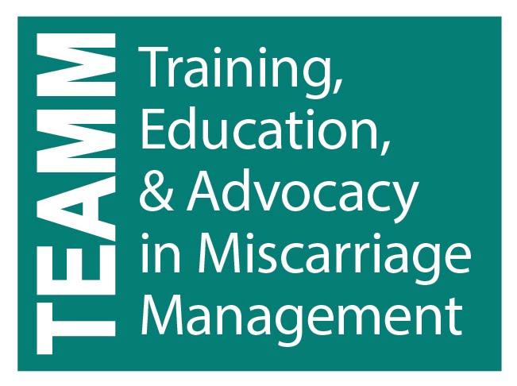

EPL Management Options: Advantages, Disadvantages, and Efficacy

A person’s feelings about early pregnancy loss (EPL) can only be understood in the context of what being pregnant and having an EPL means to them. Patients and their partners have an entire range of emotions in response to their pregnancy loss. For all, but especially for those losing a much-desired pregnancy, it is important to encourage patients and their partners to take care of themselves, surround themselves with support, and be gentle with themselves and each other.

 | Advantages | Disadvantages | Efficacy
Expectant management | - Non-invasive  - Body naturally expels non-viable pregnancy  - Avoids anesthesia and surgery risks  - Allows for patient privacy and continuity of care  - Permits treatment at home and having near support people of their choice | - Unpredictable outcome and time-frame  - Process can last weeks  - Can have prolonged bleeding and cramping  - Despite waiting may still need uterine aspiration | - Highest with miscarriage already in progress ~85-91%  - Less successful with missed abortion ~76%  - 81% SABs complete within 4 weeks, most within 2wks  - ~66% success w/ anembryonic
Medical Management (misoprostol) | - Non-invasive  - Safe  - Can be highly effective  - Avoids anesthesia and surgery risks  - Highly cost-effective  - Allows for patient privacy and continuity of care  - Permits treatment at home and having near support people of their choice | - May cause heavier or longer bleeding  - May cause short-term gastrointestinal and other side effects (less with buccal or vaginal administration)  - May still need uterine aspiration | - Highest with loss in progress ~99%  - 88% with missed Ab  - 81% with anembryonic  - (by day 8 post miso w/ up to 2 doses; 84% success by day 8 for all types)
Aspiration in office | - Predictable  - Offers fastest resolution of miscarriage  - Low risk (<5%) need for further treatment  - Pain control with local plus oral or IV meds  - May allow improved patient access and continuity of care  - Improved privacy  - Less patient and staff time  - Resource and cost savings | - Rare risks associated with invasive procedure  - Fewer pain control options in some settings  - Office procedure may be disadvantage for some  - Needs a driver for ride home | ~98%
Aspiration in OR | - Predictable  - Offers fast resolution of miscarriage  - Low risk (<5%) of needing further treatment  - Can be asleep | - Rare risks associated with invasive procedure  - Increased costs compared with office based  - More time consuming than office-based procedures  - Rare risks associated with general anesthesia  - May be more bleeding complications under general anesthesia than in office based procedures  - Needs a driver for ride home | ~98%

Counseling Steps for all methods
- Inform patient about efficacy, side effects, and risks, especially excessive bleeding and infection
- Verbal and written instructions given to all patients
- Inform patient that an aspiration procedure will be recommended if medication/expectant management fails or bleeding is ongoing and hematocrit is dropping - document this
- Rule out ectopic pregnancy
- Explain recommendation for Rhogam if Rh negative
- Provide patient with contact information for provider on-call
- Completion could be documented by ultrasonography, βhCG testing (two tests) or other clinical means but patient history may be satisfactory
  - If incomplete, may offer additional medications, aspiration or re-aspiration
- Follow up hematocrit/hemoglobin done in women with significant anemia or ongoing bleeding
- Anticipatory guidance:
  - Expectant
- Wait and see on their timeline as long as they are stable without contraindications
  - Medication
    - At home on their own timeline. They will be given prescriptions they need to fill at a pharmacy and instructions they need to follow.
  - Aspiration
    - Will need to pick up prescriptions for pain and anxiety, instruct to bring them to their 2 hour appointment. They will have an informational visit with a nurse, procedure visit with a clinician, and spend time in recovery. They may have a support person with them. They will need a driver at home.
- Patient education - General
  - Advise pelvic rest for 1 week
  - No evidence for delaying conception
- Future EPL risk
  - 1 SAb – 20% (reassure that this is same risk as prior to first miscarriage)
  - 2 SAb – 28%
  - 3 SAb – 43%
- Provide contraception if desired, may begin day of aspiration or upon diagnosis of complete procedure if medical or expectant management
- Bleeding – what to expect:
  - Expectant/medication: Your bleeding should lighten and lessen after 3-5 hours of having your miscarriage
  - Medication: Advise patient to contact provider if there is no bleeding or cramping within 12-24 hours after misoprostol, advise 2nd dose. Heavy bleeding and cramping should not soak more than 2 pads an hour for 2 hours in a row and should not last more than 4 hours.
  - All management options:
    - Expect light-moderate bleeding for 1-2 weeks, bleeding usually stops after 3 weeks
    - Menses return around 4-8 weeks/fertility may return as early as 2-3 weeks
    - Contraceptive use may impact expected bleeding patterns
    - Negative βhCG values after 2-4 weeks
    - Patients report high satisfaction with any method when they had options counseling and chose the method they preferred. Dissatisfaction highest in those preferring expectant management but requiring an aspiration procedure.
    - Advise to contact 24 hours a day for any questions or concerns, especially:
      - too much bleeding (soaking more than 2 regular pads an hour for 2 hours in a row)
      - fever over 100.4°F or if it is persistent more than 8 hours after a misoprostol dose
      - Fainting
      - lower abdominal pain and feeling ill in the days after the cramping and bleeding are over
      - Pain that cannot be managed at home with prescribed pain medication
    - Follow-up:
      - Schedule 1 week appointment to assess coping and ensure complete process (beta, US, pre-conception, contraceptive) *expectant management may be by phone until after miscarriage
      - Provide contact information

Rates of successfully completed miscarriage using expectant management or misoprostol by subcategory of early pregnancy loss from day of diagnosis: (adapted from Luise/Zhang)

 | Completed miscarriage with EXPECTANT management |  |  | Completed miscarriage after taking misoprostol by day 8
Subcategory of Early Pregnancy Loss | By day 7 | By day 14 | By day 46
Incomplete abortion | 53% | 84% | 91% | 93%
Embryonic demise | 30% | 59% | 76% | 88%
Anembryonic gestation | 25% | 52% | 66% | 81%
All categories | 40% | 70% | 81% | 84%

References:
Luise, C., Jermy, K., May, C., Costello, G., Collins, W. P., & Bourne, T. H. (2002). Outcome of expectant management of spontaneous first trimester miscarriage: observational study. BMJ (Clinical Research Ed.), 324(7342), 873–875.

Prager, S. (2011). Do nothing, do something, do surgery: Management of early pregnancy loss. Miscarriage Management Training Initiative. Seattle, WA.

Prine, L. W., & MacNaughton, H. (2011). Office management of early pregnancy loss. American Family Physician, 84(1), 75–82.

Swanson, KM. (1999). Research-based practice with women who have had miscarriages. Journal of Nursing Scholarship. 31(4), 339-345.

Wallace RR, Goodman S, Freedman LR, Dalton VK, Harris LH. (2010). Counseling women with early pregnancy failure: utilizing evidence, preserving preference. Patient Education and Counseling. In press.
Zhang, J., Gilles, J. M., Barnhart, K., Creinin, M. D., Westhoff, C., & Frederick, M. M. (2005). A comparison of medical management with misoprostol and surgical management for early pregnancy failure. The New England Journal of Medicine, 353(8), 761–769. doi:10.1056/NEJMoa044064

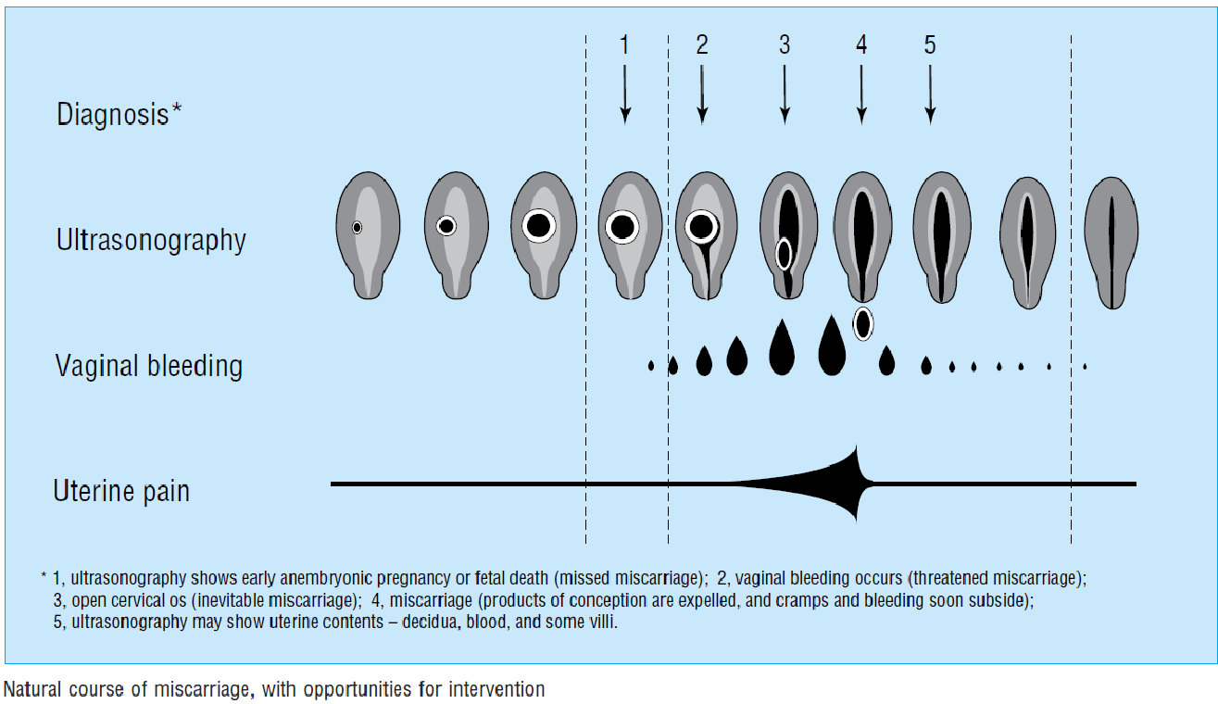

Ankum, W. M. (2001). Regular review: Management of spontaneous miscarriage in the first trimester: an example of putting informed shared decision making into practice. BMJ, 322(7298), 1343–1346. doi:10.1136/bmj.322.7298.1343

Luise, C., Jermy, K., May, C., Costello, G., Collins, W. P., & Bourne, T. H. (2002). Outcome of expectant management of spontaneous first trimester miscarriage: observational study. BMJ (Clinical Research Ed.), 324(7342), 873–875.

Prine, L. W., & MacNaughton, H. (2011). Office management of early pregnancy loss. American Family Physician, 84(1), 75–82.

Zhang, J., Gilles, J. M., Barnhart, K., Creinin, M. D., Westhoff, C., & Frederick, M. M. (2005). A comparison of medical management with misoprostol and surgical management for early pregnancy failure. The New England Journal of Medicine, 353(8), 761–769. doi:10.1056/NEJMoa044064

