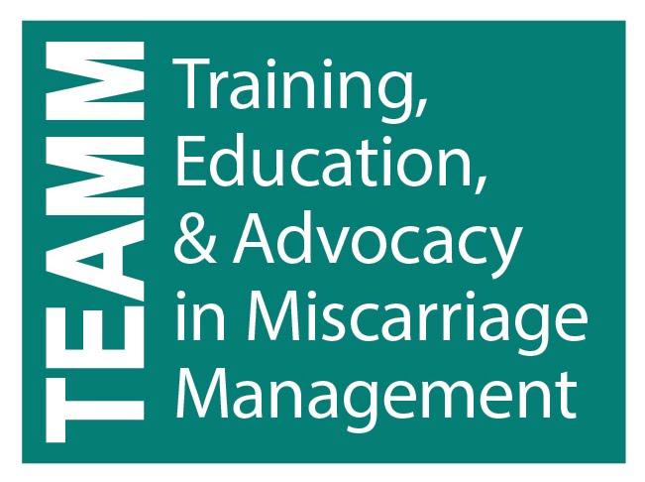

Emotional Support Resources for Early Pregnancy Loss

Keep in mind that a range of emotions are normal for those experiencing miscarriage. These emotions may include grief, sadness, ambivalence, and/or relief. Ask questions to better understand your patients’ feelings in order to assess how you can best provide compassionate and supportive care.

Consider working with or forming a perinatal bereavement team at your clinical site to create resources for families experiencing miscarriage, which may be very helpful in putting together a resource list and suggestions for caregivers that are caring for EPL patients specific to your local resources.

Consider creating a memory box or comfort kit, or something tangible to offer to patients who express feelings of loss related to their miscarriage. A box or kit may provide comfort immediately or in the future. If the patient does not want it at the time of their visit, consider keeping it for 6-12 months, as some people may ask about it at a follow-up visit. Items to consider including in the box:
- Copy of the ultrasound
- Small charm (Heart, stone, etc.)
- Kleenex
- Forget-me-not seeds

Resources to have available:
- Written information about EPL to share with family
- List of local support groups and resources (see below for ideas)
- Name of Hospital social worker and/or chaplain
- Websites and social media platforms often have excellent opportunities to read other people’s stories and connect with peers

Your clinical site might also consider sending a hand-written note to patients after their miscarriage expressing your condolences.

Research and know your options for patients requesting to take the pregnancy tissue home as well as options for cremation.

Recommended Resources to Share with Patients

Parent Support of Puget Sound
http://psofpugetsound.org/
Washington-based organization providing resources and peer support for people who have experienced a miscarriage, stillbirth or infant loss. Similar groups are available in many communities.

All Options
https://www.all-options.org
Peer-based counseling and support talk line where all decisions and experiences of pregnancy can be shared. This includes experiences and choices surrounding abortion, parenting, adoption, pregnancy loss and infertility.

Faces of Loss
http://facesofloss.com/
A place for those experiencing pregnancy loss, stillbirth and infant loss to share their written story and to find resources and support.

The Miscarriage Association
https://www.miscarriageassociation.org.uk
UK-based support organization that offers many resources to help families cope with miscarriage and to spread awareness of miscarriage. They use the general term miscarriage but include support for those who have had an ectopic pregnancy or molar pregnancy as well.

Miscarriage Support Auckland Inc.
https://www.miscarriagesupport.org.nz
Miscarriage support resource for patients and healthcare providers. Though they provide resources for their region (Aukland, New Zealand), their comprehensive website can serve all.

Share Pregnancy and Infant Loss Support
http://nationalshare.org
Provides information, education and resources for families and caregivers surrounding pregnancy loss, stillbirth and death of an infant. They sponsor support groups throughout the country and have resources available online in English and Spanish.

Through the Heart
https://www.throughtheheart.org
Peer-to-peer support and resources for those experiencing pregnancy loss. Can be a resource for providing “Comfort Kits” for women experiencing a loss.

Unspoken Grief
http://unspokengrief.com
Peer-to-peer website that provides a safe place to share, talk, support and learn about the impact of miscarriage, stillbirth and neonatal loss.

